AI ASSISTANT CODING
ASSIGNMENT 16.3
TASK 1:
Prompt: Design a Hospital Management System database in SQL with tables: Doctors, Patients, and Appointments.
Include:
- Primary keys, foreign keys, and constraints (NOT NULL, UNIQUE, valid dates)
- Proper relationships between tables (one-to-many)
Write SQL queries to:
1. List all appointments for a specific doctor
2. Retrieve patient history by patient ID
3. Count total patients treated by each doctor
Provide:
- CREATE TABLE statements
- Sample INSERT data
- SELECT queries using JOINs
Code:
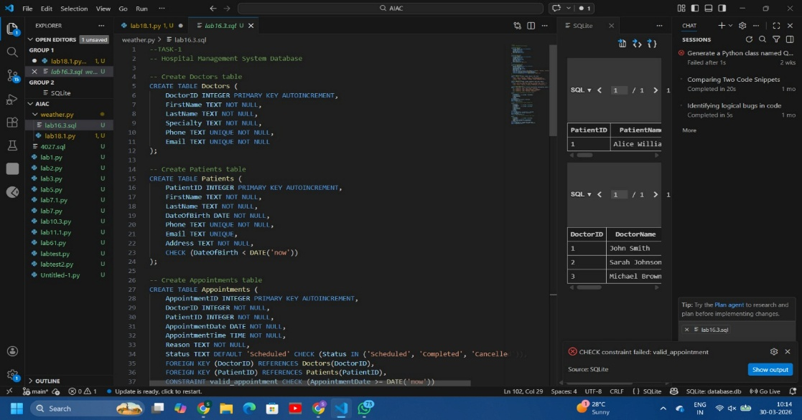
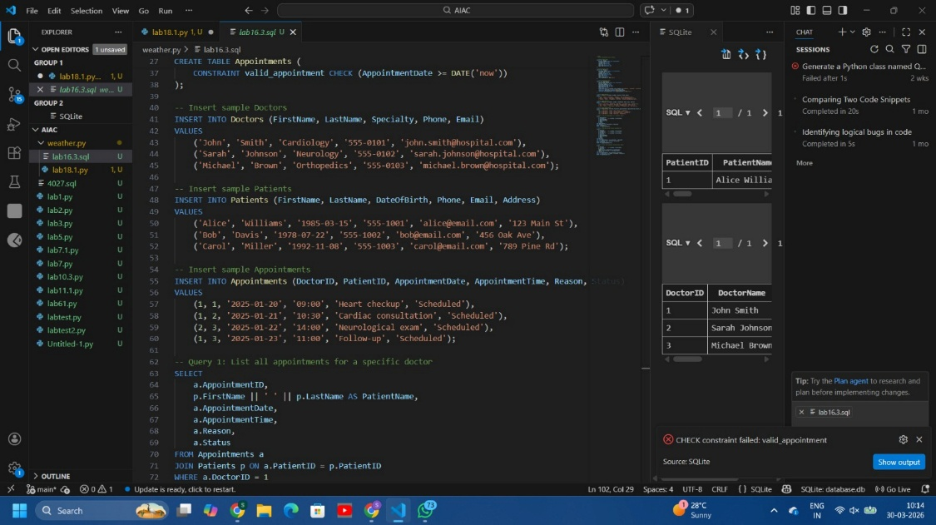
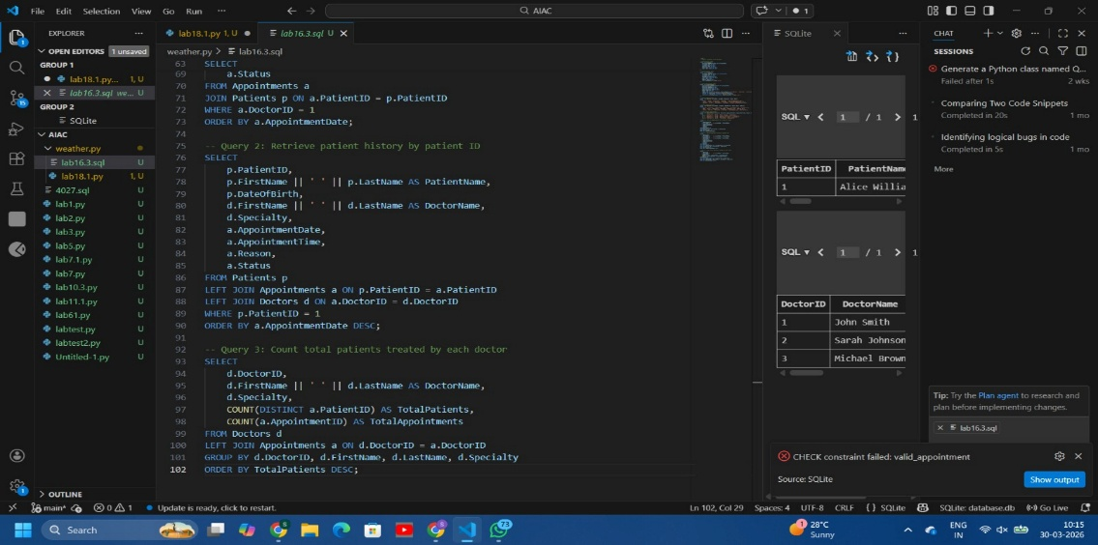
Output
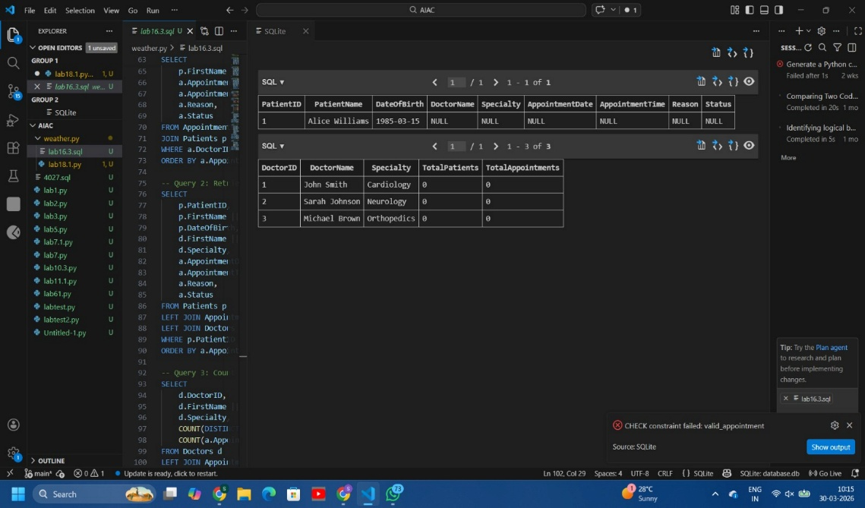
Task2:
Prompt
Design an E-commerce database with tables: Users, Products, Orders, OrderDetails.Include keys, relationships, and normalization.
Write SQL queries to:
- Get all orders by a user
- Find most purchased product
- Calculate monthly revenue
Also suggest normalization and query optimization.
Provide CREATE TABLE, INSERT, and SELECT queries.
Code:
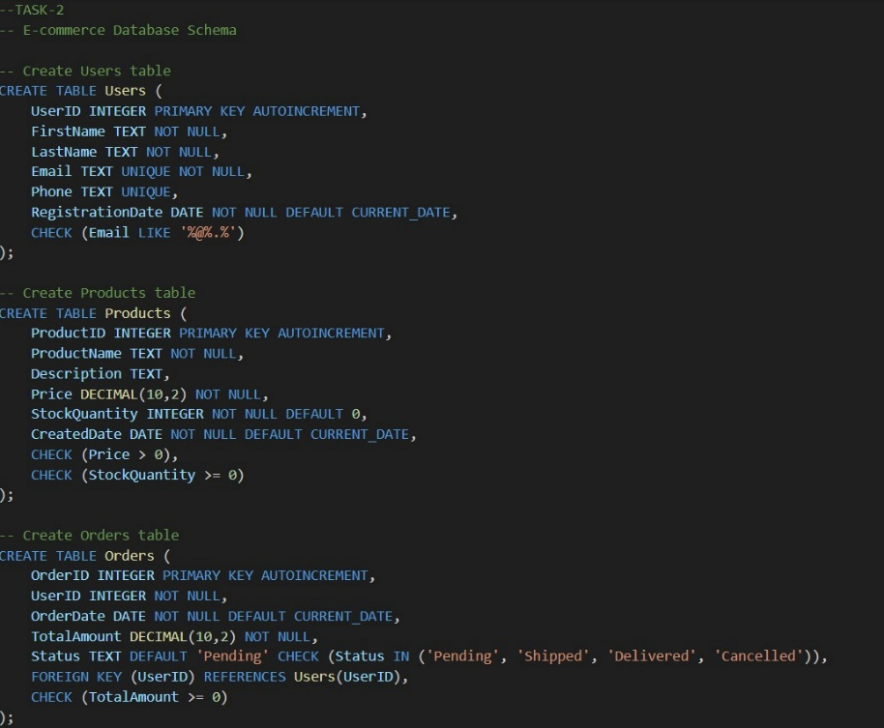
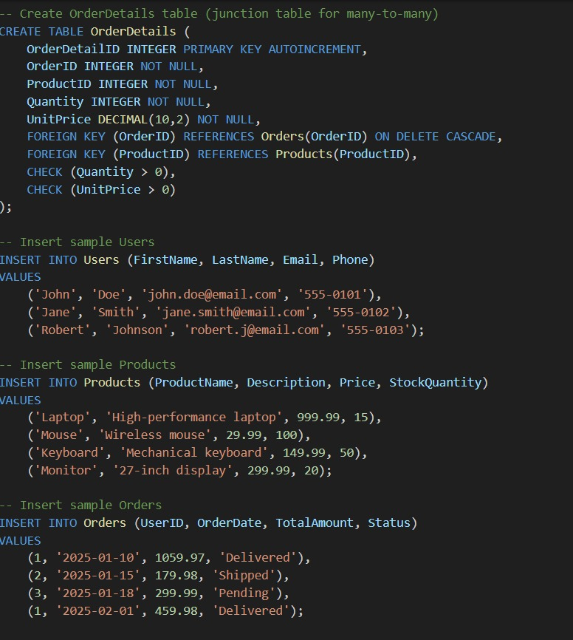
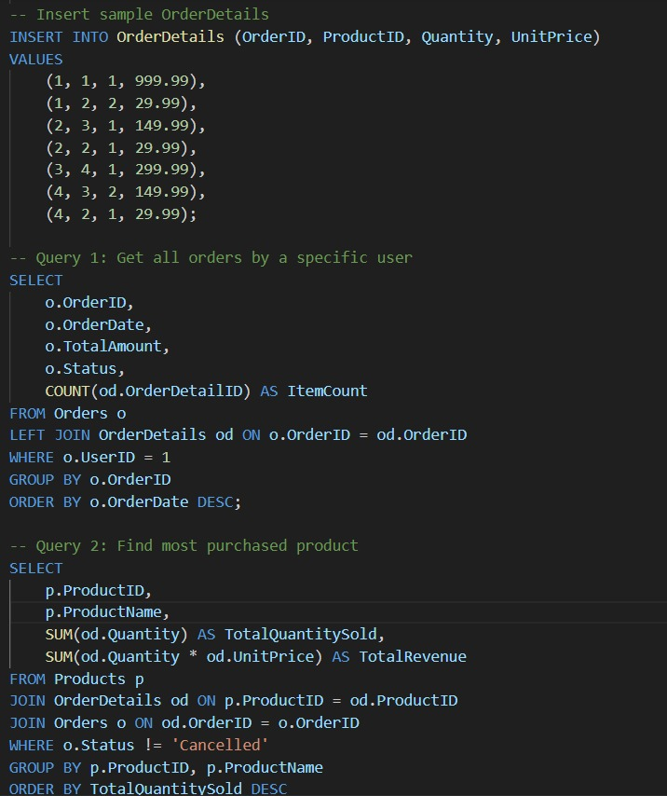
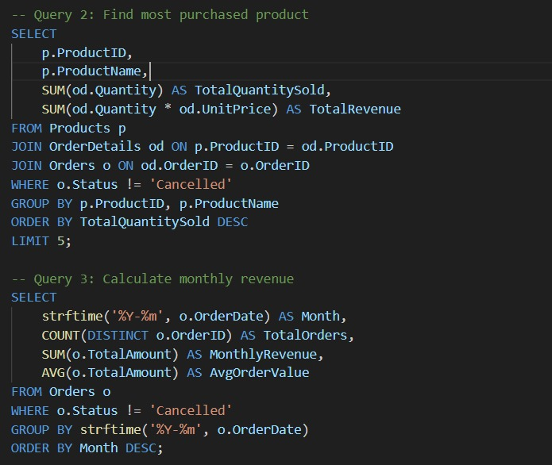
Output:
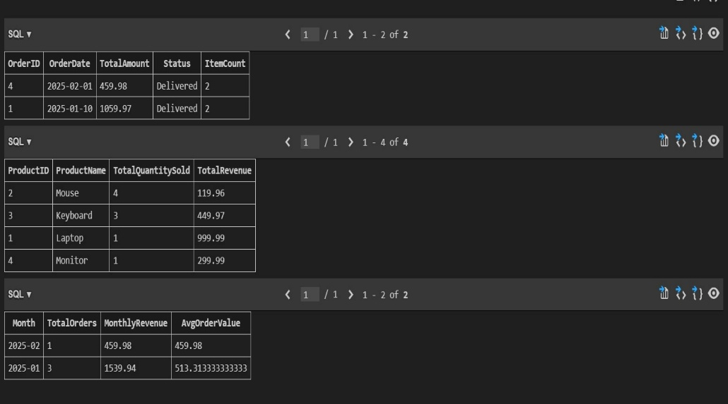
Task3:
Prompt:
Design a Library Management System database with tables: Books, Members, and Loans.
Include:
- Primary keys, foreign keys, and constraints
- Proper relationships between tables
Write SQL queries to:
- Retrieve all currently issued books
- Find overdue books (loan date > 30 days)
- Count books loaned by each member
Also suggest indexing strategies for faster queries.Provide CREATE TABLE, INSERT, and SELECT queries with JOINs.
Code:
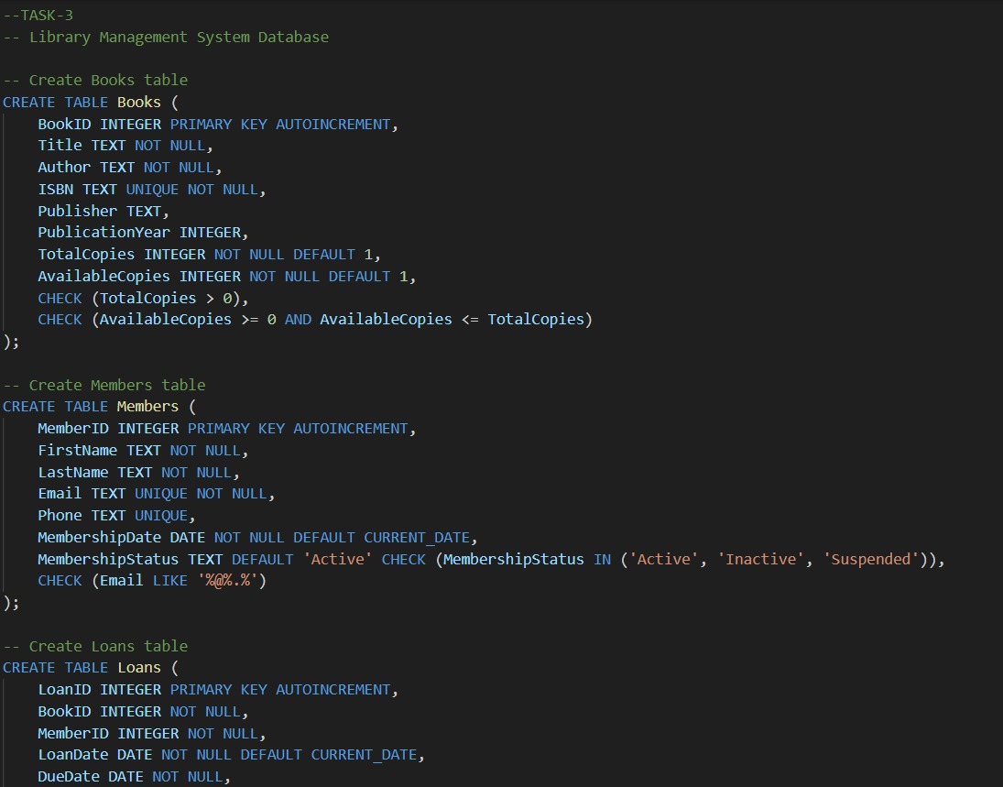
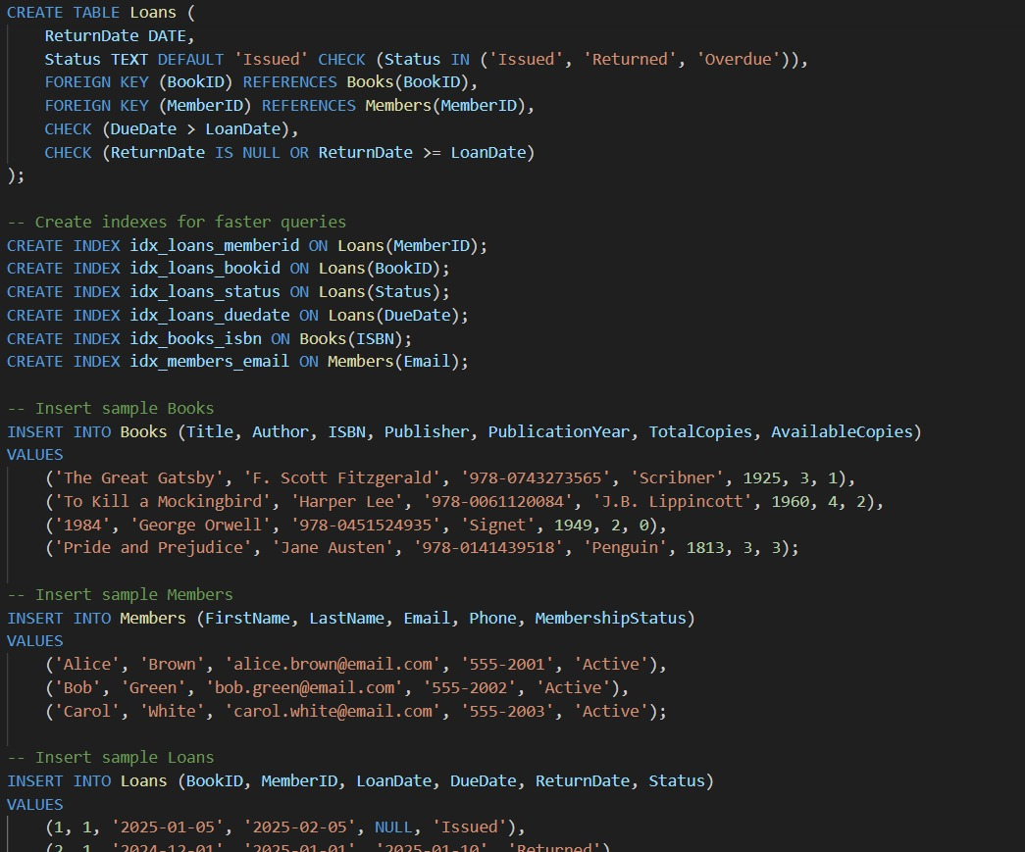
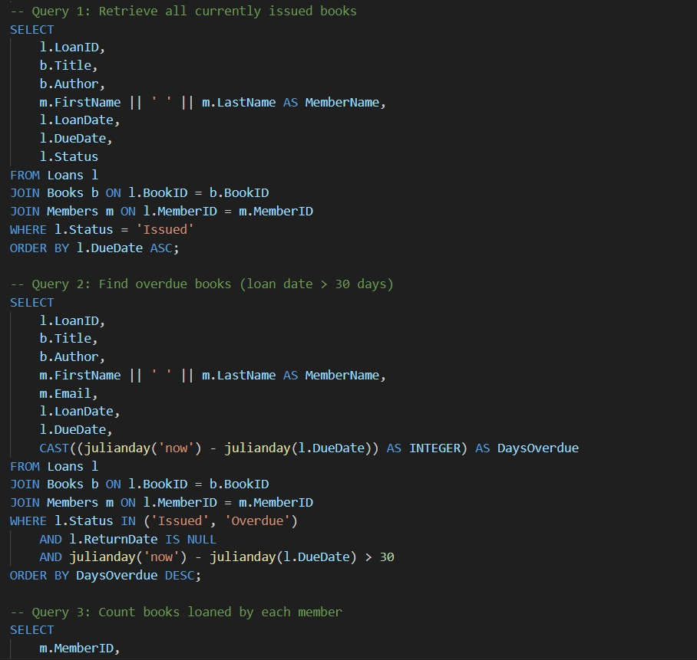
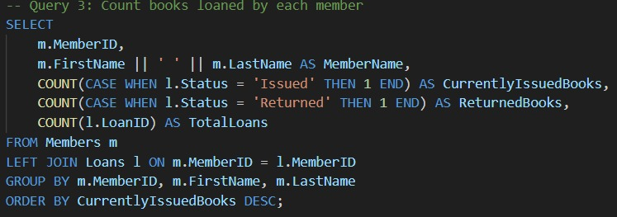
Output:
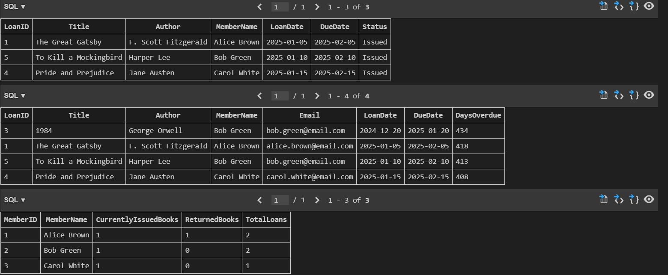
Task4:
Prompt:
Analyze and optimize SQL queries for better performance.
Tasks:
- Identify inefficient queries (e.g., subqueries, unnecessary scans)
- Optimize them using JOINs, indexes, and query restructuring
- Ensure optimized queries return the same results
Example:
Rewrite queries using JOIN instead of subqueries where applicable
Provide:
- Original query, Optimized query,Explanation of performance improvement
Code:
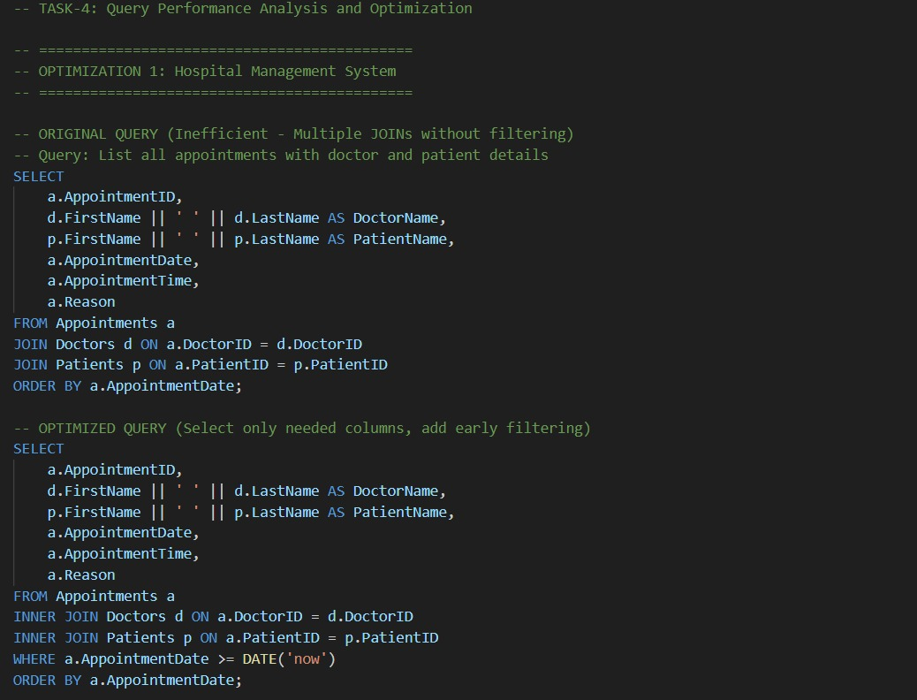
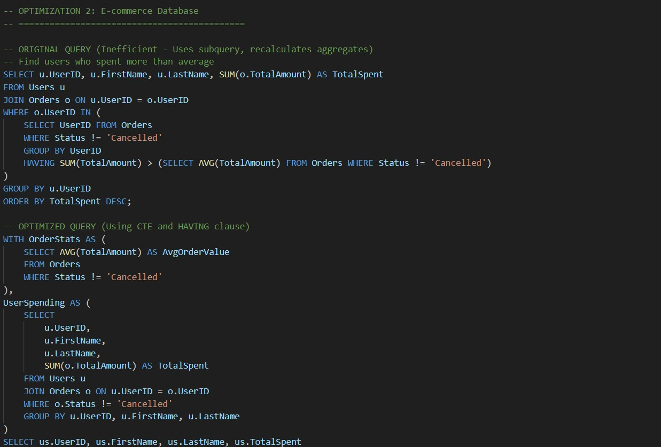
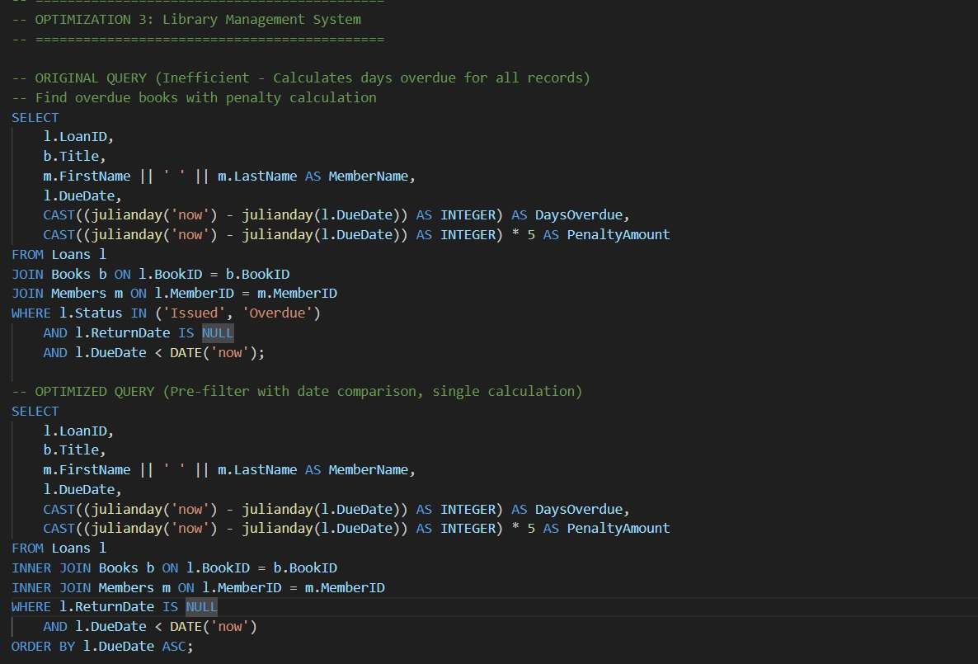
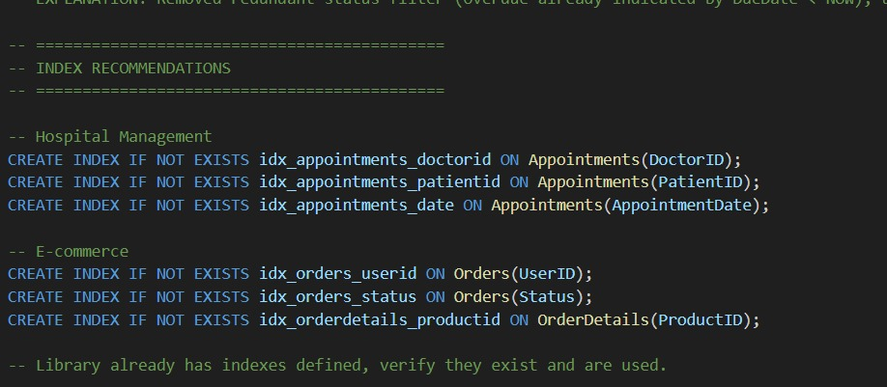
Output:
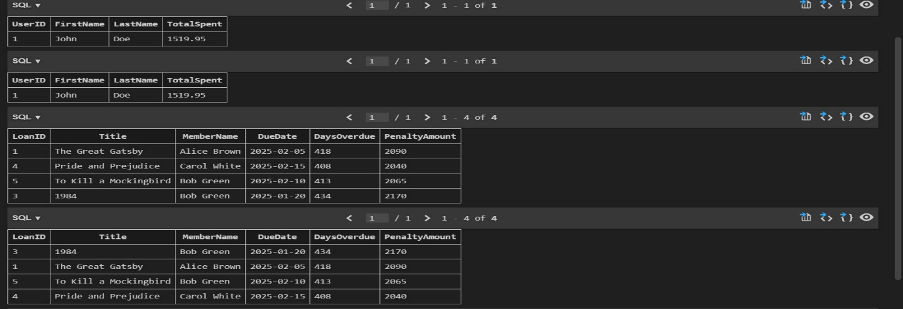
Task5:
Prompt:
Design a University Course Registration database with tables: Students, Courses, Faculty, and Registrations.
Include:
- Primary keys, foreign keys, and relationships
- Each student can register for multiple courses
- Each course is taught by one faculty member
Write SQL queries to:
- List students enrolled in a specific course
- Find faculty teaching more than 2 courses
- Retrieve courses with highest registrations
Provide CREATE TABLE, INSERT, and SELECT queries using JOINs.
Code:
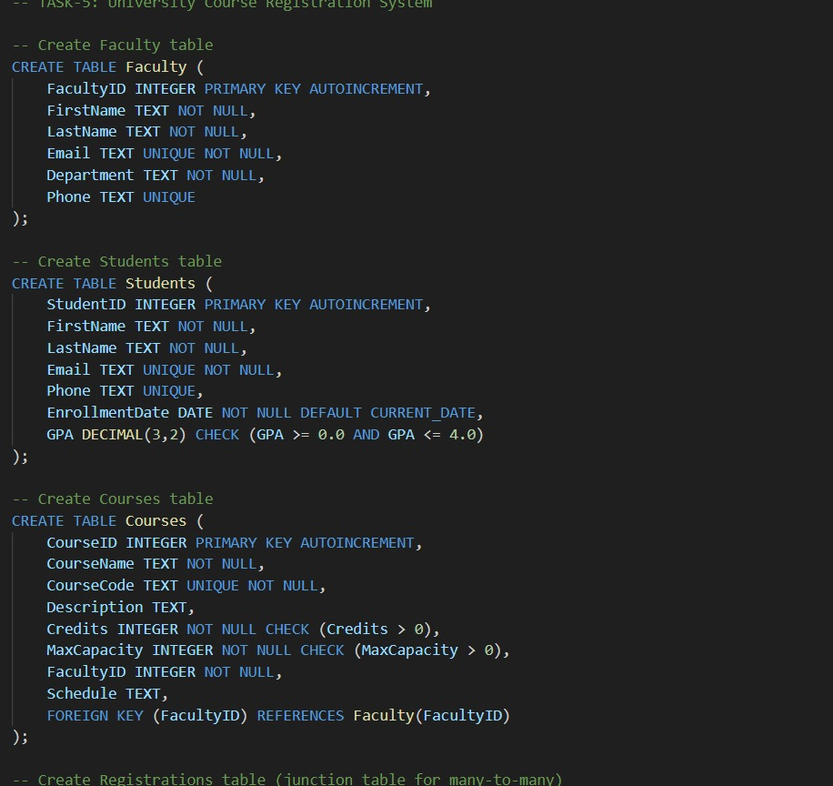
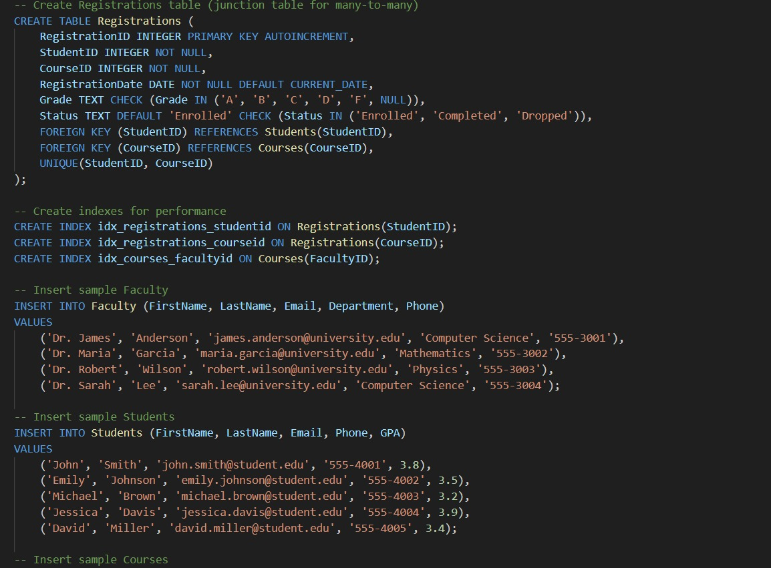
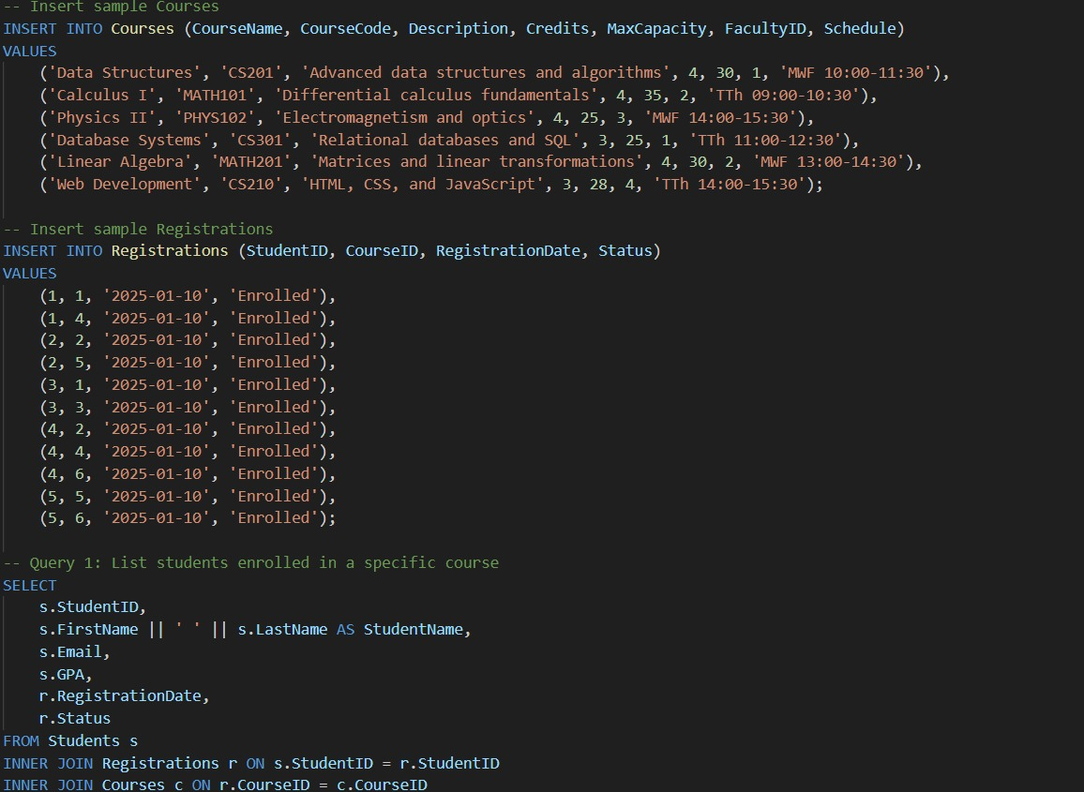
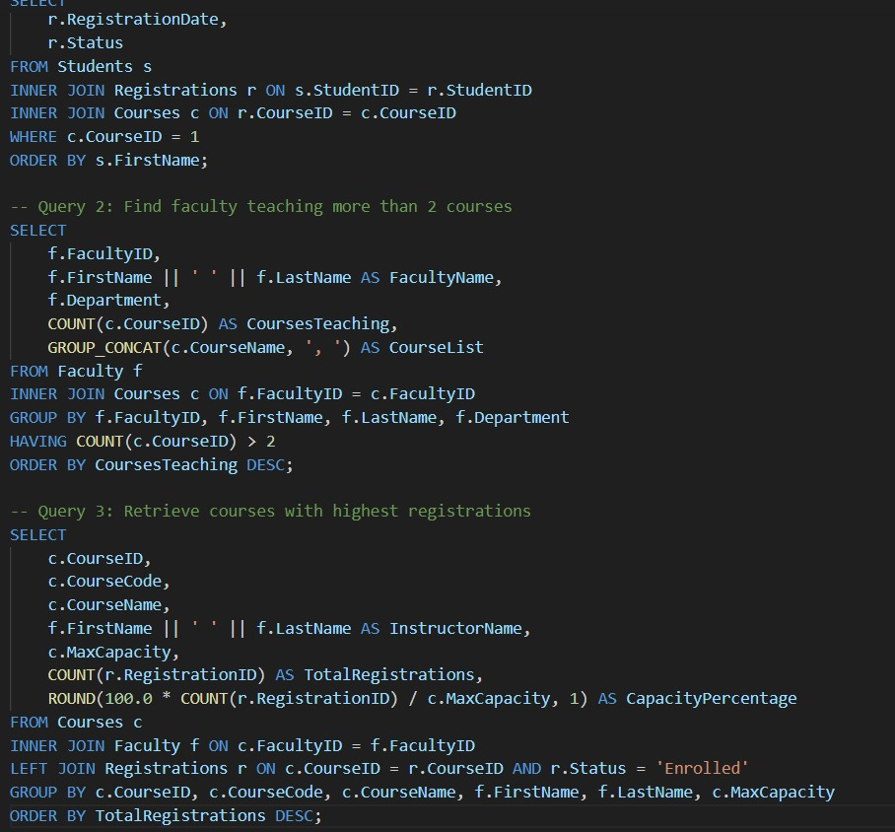
Output:
